STRANDED

This a Mod of the PC game Unreal Tournament 3 in which the player will experience the terror of exploring a stricken military ship crawling with hideous creatures.

Taking the role of Dominic Travis, a pirate and scavenger, the player must attempt to survive the horrors of the USS Victory, a ship that seemed an easy target, but turned out to be the site of a disastrous accident, brought about by the experimental military weapon which it was carrying .

This document details the style and feel of the game, and the ways in which we will create the game using the Unreal Tournament 3 game engine.
2009
A Grade Games

11/18/2009

Contents
Story 3
Concept 4
Gameplay 4
Characters 4
Main Character 4
Implementation 6
Target Audience 6
Sound 7
Level Image 7
Another image of the cave section. 9
Level Design Sketches 12
Bridge 12
Corridor 12
Corridor2 14
Room 15
Game Resources 16
Level complexity 16
Level descriptions 17
Beach and Island 17
Beach and Island Resources 17
Bridge 18
Bridge Resources 21
Crews Quarters and Mess Hall 21
Crews Quarters and Mess Hall Resources 24
Medical and Armory 24
Communications Deck 25
Engine Room 25
Cargo Hold 26
HUD 27
Semester 2 schedule 27

Story
The player takes control of the small time smuggler/pirate Dominic Travis, who, as his profession suggests, is an opportunist. Whilst refueling his ship at a small port he overhears that a military ship called the USS Victory has went missing and that thus far all searches have proved fruitless. Feeling that this is too good an opportunity t be passed up, he convinces his crew that this could be the job they’ve been waiting for; even standard equipment that could be salvaged on these types of ships would bring in a small fortune, but the rumor is that this ship was carrying something else; new, experimental, and above all expensive.
The crew set off in the hope of finding the stricken vessel before anyone else, but just a few hours out to sea they are hit by a sudden violent storm. The small ship is torn apart and Dominic wakes up on a small island, alone, with no equipment, and the only signs of any human life on the island is the wrecked military ship he can see that has run aground off in the distance.

Concept
This is a third person action horror game which is set in present day and takes place on a wrecked military ship on a small island in the Atlantic Ocean. The game will allow the player to explore this ship and the surrounding island in search for valuable military equipment and clues to what happened to the crews of both his ship and the military vessel. The game play will be linear in its implementation with the story propelling the player through the levels. We will create a tense atmosphere using lighting and sound to make the player share the fear Dominic experiences as he makes his way to the bowel of the ship.

The game will be a mod of the Unreal Tournament 3 game for the PC.

Gameplay
The game will start off with a slow pace to let the player become accustomed to the controls and to build the tension as before the player encounters the first enemy. A small training area will be put in place to aid the player. After this the player will make their way on board the ship, and by completing a number of tasks they will make their way to the cargo hold to get their hands on the military equipment.

From the beginning the player will have melee weapons to fend off the initial enemies which will be a rival crew of raiders who arrived at the island at the same time. As the story progresses the player will have access to weapons found on the ship such as pistols etc. and will encounter the mutated crew of the ship once inside the ship (Whatever military secrets were on board seems to be the cause of their violent and horrible mutation).

To keep the gameplay tense and exciting for the player there will be few enemies to begin with, but each pose a serious threat to the player as they are so ill equipped for battle. As the player progresses they will be able to fight off more creatures with the weaponry they have secured form the ship.

Starting out as a mission to raid and salvage a ship, it quickly evolves into a fight to survive and escape the island, while trying to find any surviving members of your crew.

The player will find ammo and guns throughout the ship; however the amount of ammo to be found on the first few levels will be sparse.

The player will have a set health bar which can be replenished with the use of first aid kits which can be found throughout the ship. The will be found in places where the player encounters difficult or numerous enemies. Body armour can also be found but this is finite and will be discarded when is has taken a set amount of damage.

Characters

Main Character

Name Dominic Travis
Age 32
Height 6 foot 1
Hair Black
Eyes Brown
Build Athletic

Dominic Travis is a scavenger. Look deeper into his dealings however and you will find that what he does for a living is more likely to fall under the category of pirate. To make ends meet he will scour the seas in search of anything of value what so ever and, failing that, he will take what he wants from those he encounters in the open water.

Dominic had a fairly normal upbringing. Growing up just outside of Chicago, he found out at a young age that he was not satisfied just playing with friends and going to school as any other child would be. He craved excitement and would do just about anything to get it. Inevitably this led to much trouble with the police and after being caught breaking and entering several houses at the age of 14 he landed himself in a juvenile detention centre. This was the last straw for his parents and so decided to send him away to live with relatives on the west coast, but when Dominic learned of these plans he ran away from home to seek his fortune.

Now at the age of 32, he runs a small crew who will each do whatever it takes to make their fortune. His conscience is the only thing that stops his crew running riot and simply killing those they steal from, but the very nature of their job means that violence is never far away, making him skilled with both melee weapons and small arms. Although Dominic has always been a bit of a loaner, he has one good friend in the crew, his first mate Martin. He captains the ship Anova.

Name James Fuller
Age 48
Height 5 foot 10
Hair Dirty blonde
Eyes Blue
Build Overweight

James Fuller is the leader of a ruthless band of killers and thugs who take to the seas in search of riches, much like Dominic’s crew. The difference being however that he and his large crew delight in the torture and murder of all those they encounter while at sea. He is feared by all those who make a living transporting anything of value what so ever by ship, and once he marks his target he pursues them like a rabid dog, killing all on board and taking whatever he can sell. He captains the ship Relentless.

Name Martin Hicks
Age 36
Height 6 foot 3
Hair Brown
Eyes Brown
Build Slim

Martin Hicks is the first mate on board the Anova and best friend to Dominic. He has been with the ship since the beginning, while the other members of the crew have changed for numerous reasons over the years, he has stuck by Dominic through thick and thin. Although he can be at times incredibly violent and difficult to get along with, Dominic seems to know how best to keep this in check, for the good of the whole crew and those they rob.

James Fullers crew will be of various shapes and sizes although the violent captain prizes a dominating physical presence in those he employs so most are gifted with an abundance of muscle and below average intelligence, making them ideal for mindlessly obeying even the most sadistic of orders. They generally don’t go for tactics but tend to stick together wherever possible. Most carry clubs or knives and occasionally small arms.

For the other set of enemies it will be the transformed crew of the military ship, changed by experimental weapon they were transporting. They are zombie like in nature, no concept of teamwork, simply killing anyone they encounter. The will still retain the ability to wield weapons such as guns to keep the gameplay exciting.

Implementation

We will use the Unreal Tournament 3 engine to create the game and employ a mutator to allow the 3rd person look. This mutator will be used throughout the full game.

We will also use 3d models with which we have permission to use. These will be taken from the likes of google warehouse and the unreal game itself to allow us to create the game we have envisioned. The group has a limited amount of experience with 3d modeling and so we decided this would be the best course of action to take.

We will use the matinee function of the UT3 engine to create the cut scenes which will animate the crucial plat points.

Scripting will be used to allow use to control the movements and behaviours of the enemies.

Target Audience

This game will have a horror theme with violence throughout and so the game is targeted at a more mature audience. This allows us to make a game in which the player can immerse themselves and enjoy the adult storyline.

The game will be familiar and popular with those who have previously played titles such as “Resident Evil” and so we know that a game of this type will be well received.

Sound

Fop the sound effects used in this game will be from a variety of sources which offer free to uses effects and noises. We will use noises in conjunction with trigger events to create the effects such as doors opening etc, as well as sounds for water, gunfire and enemies.
To create ambience, and give the player the tense fearful experience we are setting out to achieve, we will use several background tracks which will be heard throughout the game.

Level Image

  - Cave
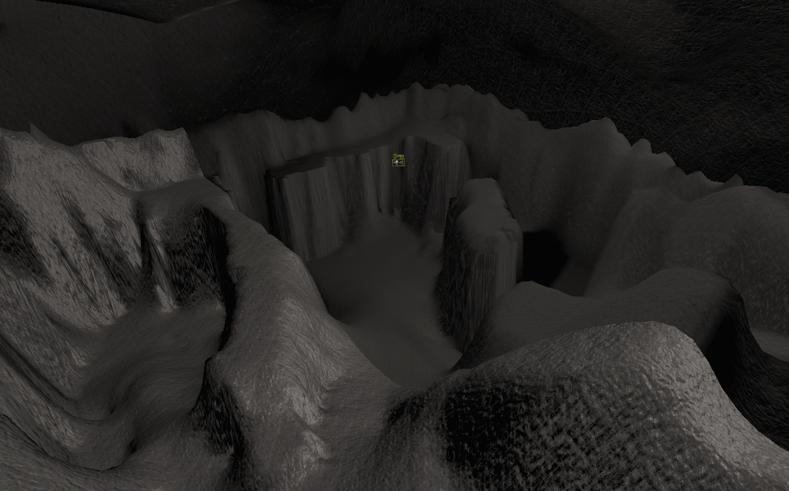

An image of the cave section of the first level

  - Cave 2

Another image of the cave section.

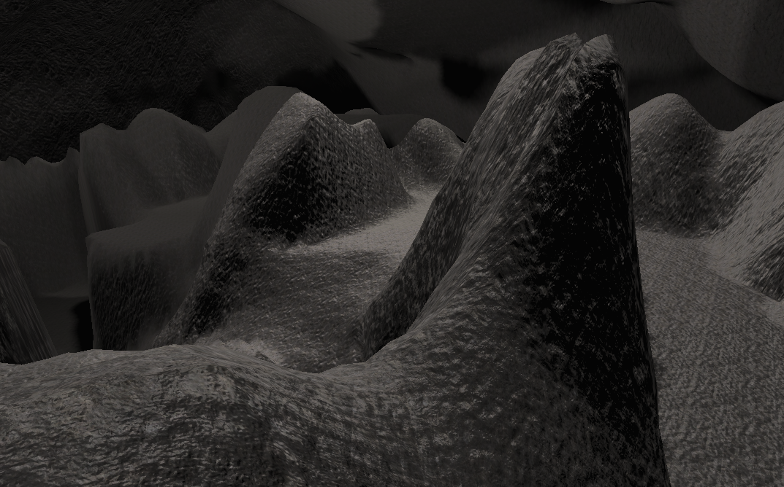

Ship Interior

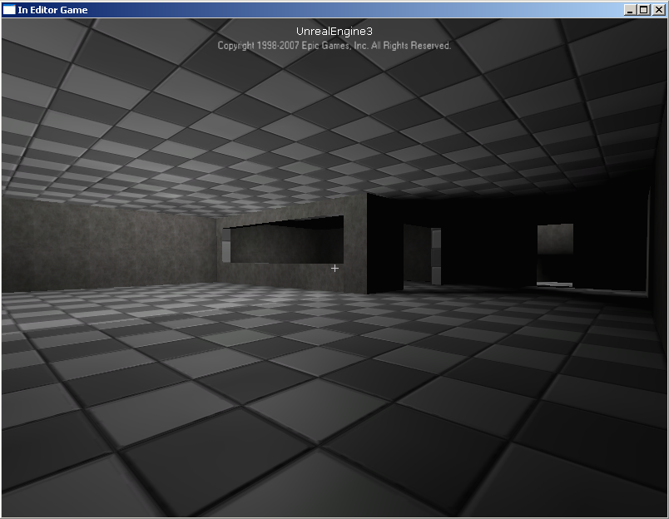

An idea of how the Interior of the ship will look

  - Ship Interior 2

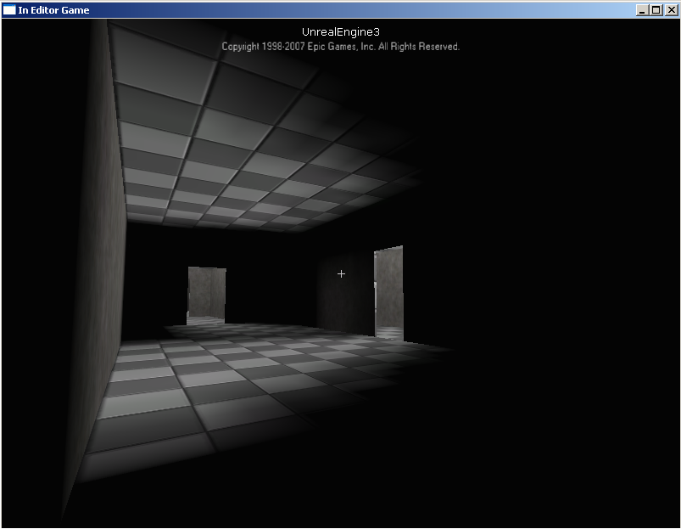

This illustrates the dark narrow corridors which will be prominent in this game.

Level Design Sketches

Bridge
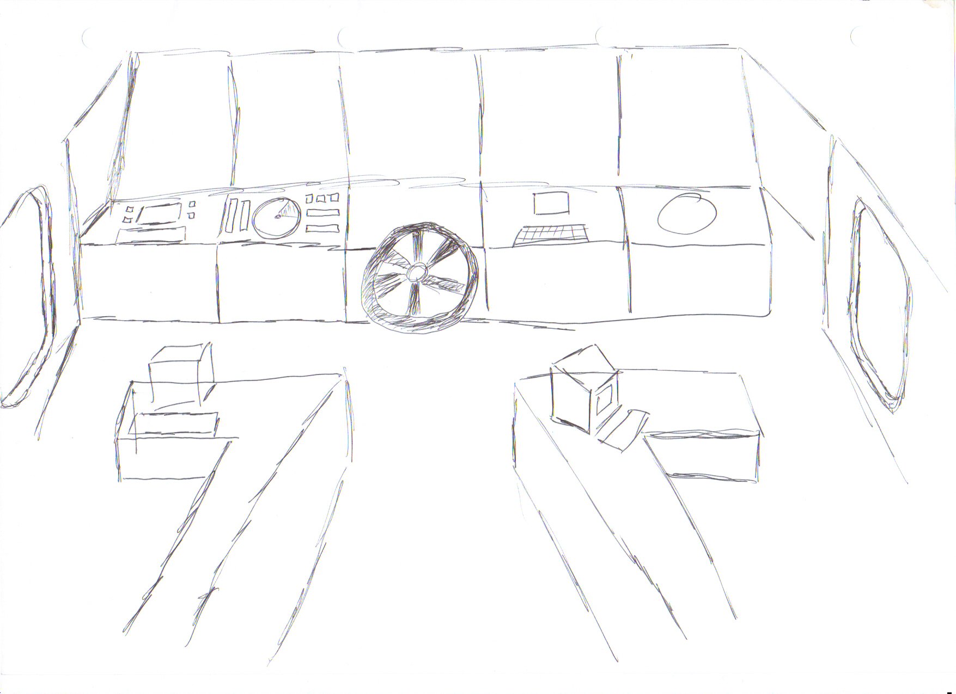

- Large room
- Several Consoles
- Desks
- Well lit due to the windows

Corridor

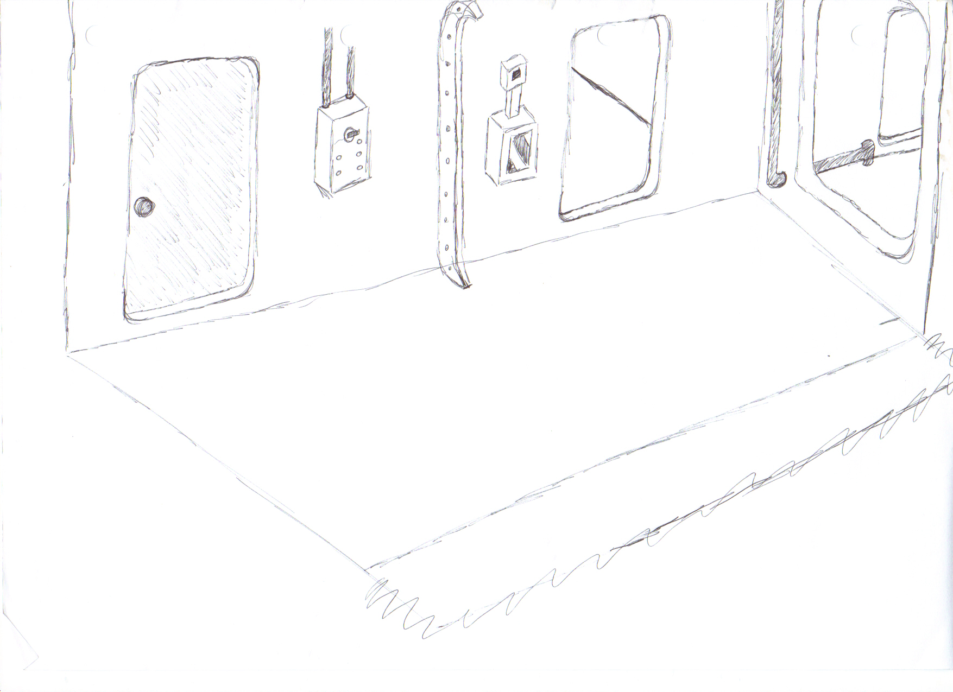

- Long corridors
- Metallic
- Dim, poorly lit
- Flickering lights
- Many doors coming off main corridors

Corridor2

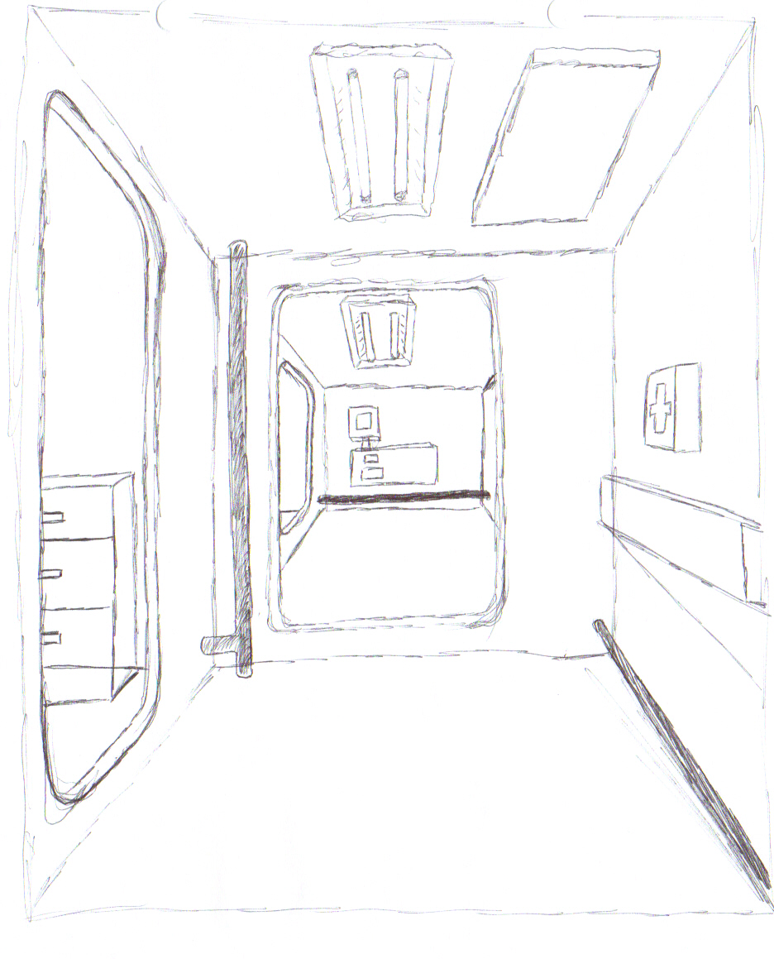

- Small, confined area
- 90 degree turns

Room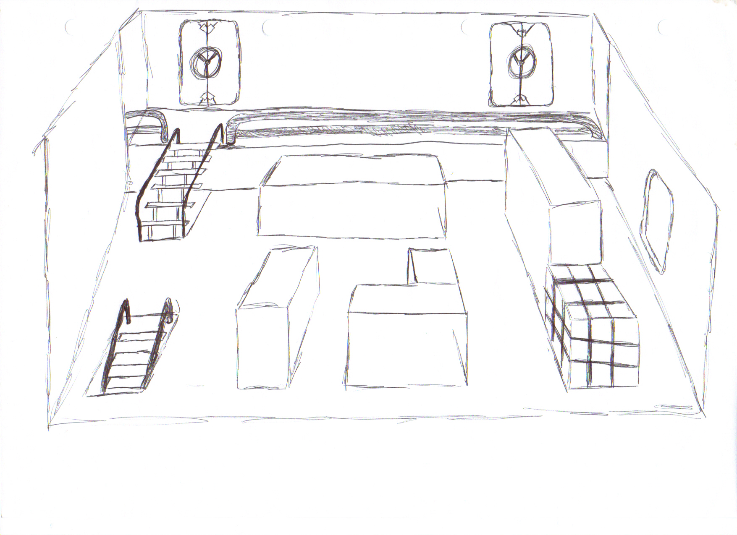

- Storage room/ room to lower level
- Metallic walls and floor
- Storage crates and general debris scattered around
- Only 1 or 2 spot lights to create atmosphere

Game Resources

For the ut3 mod we are designing, we will need to import resources; over and above the ones provided within the engine.

We will need to import several things:

Sound effects - for the enemies and some of the weapons.
- For the wildlife effects on the island
- For the sound of the ocean and water.

Models - A model of a large vessel for the exterior of the ship.
- Models for the main character and some of the enemies.
- For the weaponry in the game, specifically the melee weapons.

Level complexity

Bridge - Outdoor and indoor sections.
Specific lighting and small matinee sequence.
Fairly small size of level.

Crew Quarters - Fairly simple uniform level layout.
Similar textures throughout.
Simple lighting.

Medical and Armory- Large level with complex design.
Both medical and armory have different textures and lighting.

Communication Deck - Level design of moderate complexity, several rooms of varying size.
Several doors and items to deal with, as well as a mixture of lighting effects.
Similar textures throughout.

Engine Room - Large area with only a few rooms but several levels.
Will include ladders and water effects.
Small matinee sequence.

Cargo Hold - One large room with uniform textures and lighting.
Small matinee sequence.

Level descriptions

Beach and Island
The first level is to familiarize the player with the controls and gameplay in general. The player starts on the islands’ beach with no weapons or equipment. The level will be large and appear to be an open environment but we will use the terrain to constrict the players’ movements and allow them to reach their goal without getting lost.
The Level will consist of a body of water behind the players starting point and an expanse of uneven mountainous terrain. Foliage will be added the terrain to make it appear more like a tropical island, than simply barren land. Sound will be played emanating from the water. After traversing a small valley like section, the player will be able to “climb” a rock face as it is covered in vines, this will lead to another valley section with trees and bushes which, in turn, leads to a much wider area. This is the shipyard; an area which is strewn with wreckage and machinery, as well as several cranes and of course, another expanse of water. The water will have a block which will prevent the player from swimming too far out from the main area of the level. Again a water sound effect will be played here. This area will also have several dead bodies in it to suggest to the player that you are not alone on the island. By continuing round the player will see a cave entrance, by entering this they trigger the next level to load.
This is the section where the player will be instructed on the games controls, such as how to duck, jump etc .The cave will also contain a melee weapon which the player will collect. There will be a sound trigger at this point, the sound played will be of a man shouting, to hint that there will be an enemy up ahead. After exiting the cave the player will be able to see, off in the distance, an enemy pirate. This will be the players’ first experience of combat and so it is made relatively simple for them. The enemy will be facing away from the cave so that the player can sneak up unawares and strike first. After defeating the enemy the player will continue to the final area which will be the boat which has run ashore.

Beach and Island Resources
There will be several sound files used within the first level:

1. For the sound of the Ocean at the beginning of the level Ocean.wav

2. For the ambiance and the effect of wildlife junglebird1.wav, junglebird2.wav, junglebird3.wav,junglebird4.wave, Ape.wav

Bridge
The second level of the game will have the player starting on the top deck, in the middle of the ship. The area will be large but due to various restrictions such as fallen crates and boxes etc the player only has access to a small square area of the ships deck. The player is left with the possibility of entering three doors. On one side there will be one door which leads to a small store room which contains ammo for the pistol (at this point the player has yet to find any guns.) On the opposite side of the deck the, one door will be locked and so the player must enter the second door which leads to a small poorly lit room strewn with debris.

After exiting this room on the opposite side it opens to a narrow corridor which the player can follow either left or right. To the right is a dead end with one room leading off of it. This room has one light which mainly illuminates the far corner, just outside of the pool of light a dead body will be lying. The other side direction down the corridor turns right and has several darkened rooms off of it, one of which is locked. Most of these rooms contain nothing but destroyed equipment and so the player must continue down the corridor. At he far end of the corridor, it turns right again. The player will be able to see the shadow of a figure against the back wall, which will be achieved by the positioning of a light and an enemy just out of sight. At a certain point along the corridor the player will trigger an event. This will cause the enemy to round the corner and attack the player. Once he has been defeated the player will continue to the far room which is the ships bridge. The room will be full of consoles and computers. By pressing a switch on the main consol the door to the lower level is unlocked. The door to the corridor which leads to the lower level entrance is blocked however.

On the bridge the player will find a handgun and some ammo in a storage locker in the corner and also a note which says the key to unlock the corridor has been moved to the storage room which was previously locked. As the player returns to the room an event is triggered and the previously locked room opens and an enemy pirate exits. The enemy will be armed with a gun and once defeated the player will be able to access the room and which contains another locker. This contains a health kit, key and also another note hinting that something has went wrong on board.

Now in position of the key the door to the locked corridor opens and leads left to a set of stairs, at the top of which is blocked by wooden crates, which can be destroyed by the player to proceed.

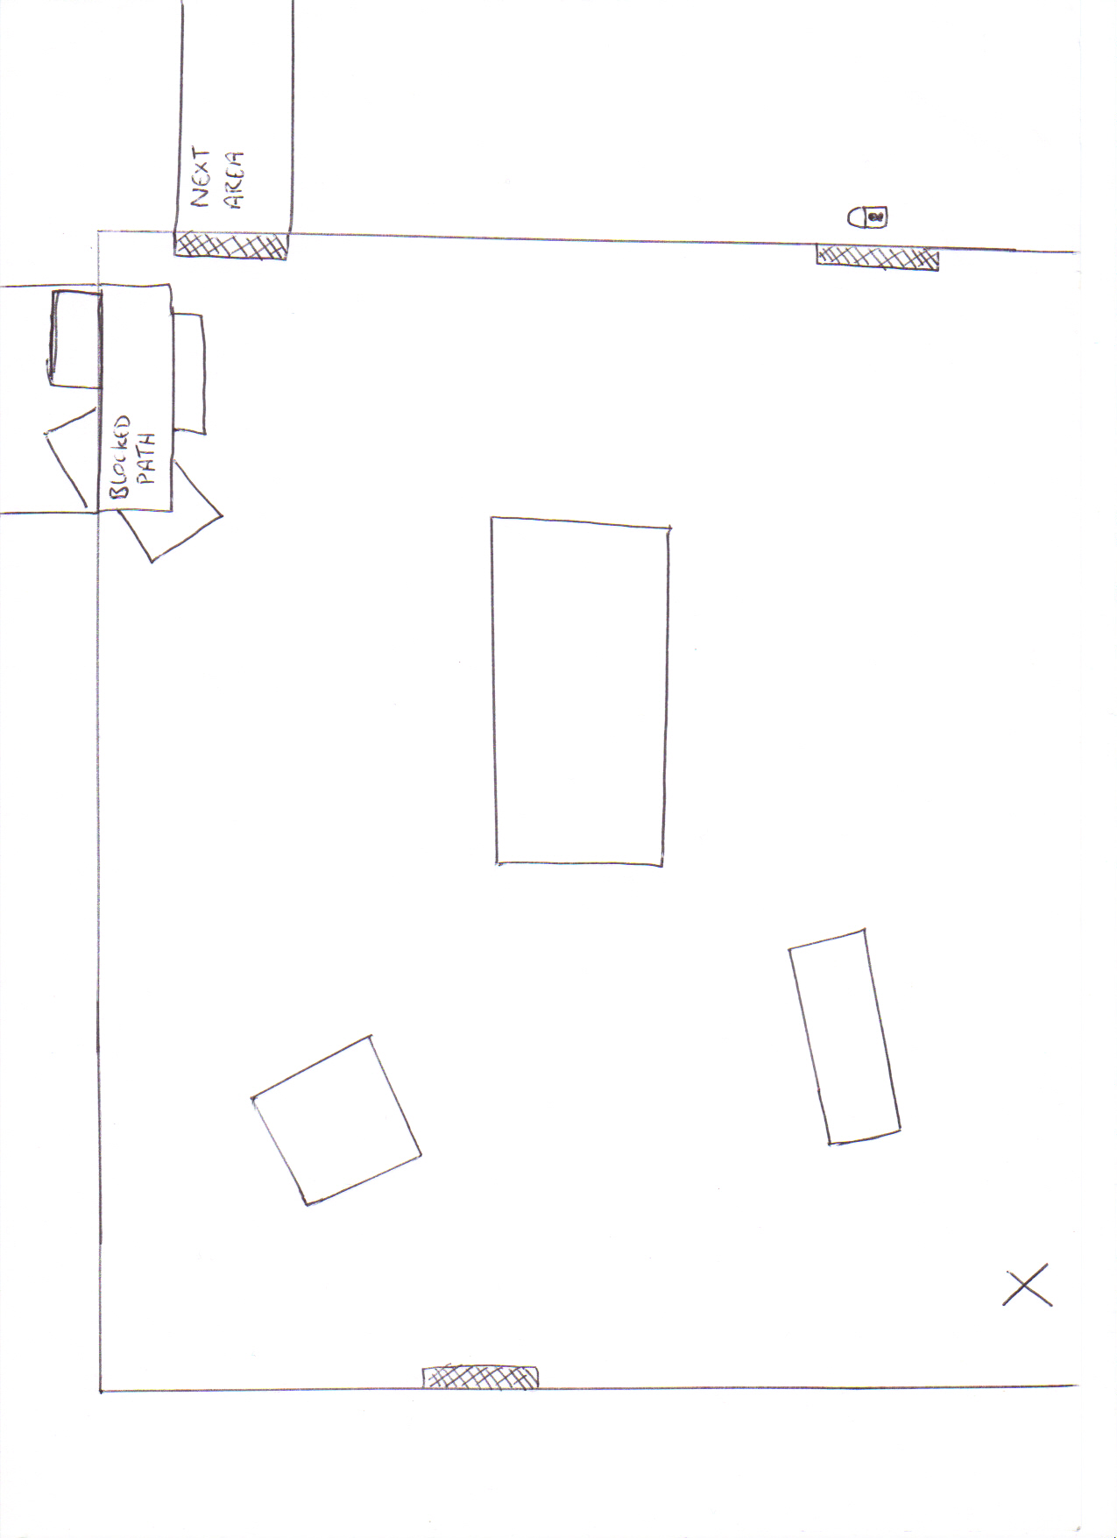
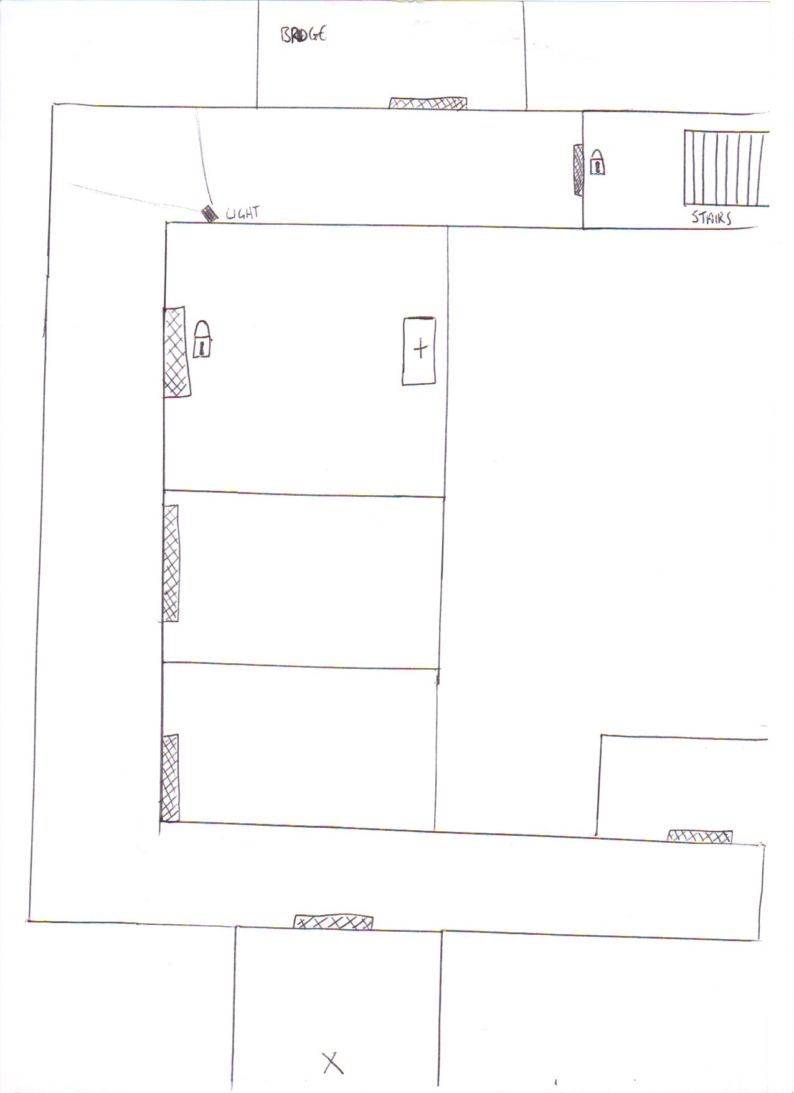

Bridge Resources

Static spot lights will be used throughout the corridors but for the shadow of the enemy on the wall a dynamic light must be put in place to allow the movement of the shadow when the enemy moves.

Notes found in level read;

- The key to access the stairwell corridor has been moved temporarily to storage room A3, adjacent to the deck door

- The captain has ordered us into lockdown, what’s going on? Things have been getting worse since the security breach but no one will tell me what’s happening!

The sounds used in this level will be:

- In the control room on the bridge, when the player enters the room Generator.wav, brokenradar.wav, static.wav.

Crews Quarters and Mess Hall
The third level begins by looking very much like the previous level; dark corridors and a maze of rooms. These rooms will be slightly larger than before as they’re the crews sleeping quarters. Each room will contain beds and cabinets in various states of disarray. The corridor loops round in a rectangular shape but the path to the right is blocked by immovable debris.

As the player proceeds through the rooms, various items can be collected, such as a key(for later in the level), ammo and several crew logs which describes some of the events which led the ship running aground. As the player progresses along the corridor, several sound triggers will play the sound of a monster growling which will get louder as the player gets closer to the door to the next section of the ship. Blocking the door to the next area is one of the mutated crew which will attack as soon as the player gets close enough. Once defeated, the player can proceed to the next room or progress along the other end of the corridor to explore the other rooms. Most will be crew quarters but one will be the toilets which will contain an enemy and a dead body. One room will be locked; the room is opened with the key found earlier in the level and allows access to this room. In it the player will find the body of a crew member, a handgun with ammunition and a heath pack.

The mess hall is large and filled with tables, chairs and other debris. The only exit at the far side of the room is blocked by a large amount of debris. When the player enters the room is well lit but as the player reaches the middle of the room, an event will be triggered, which will turn the lights in the room off. Several sounds of crashing and monsters growling will be played and after 5 second the lights will come back on to reveal three enemy crew members. Once defeated, the player can use the open air vent in the far side of the room, which the player must crouch to fit through, to progress to the next level.

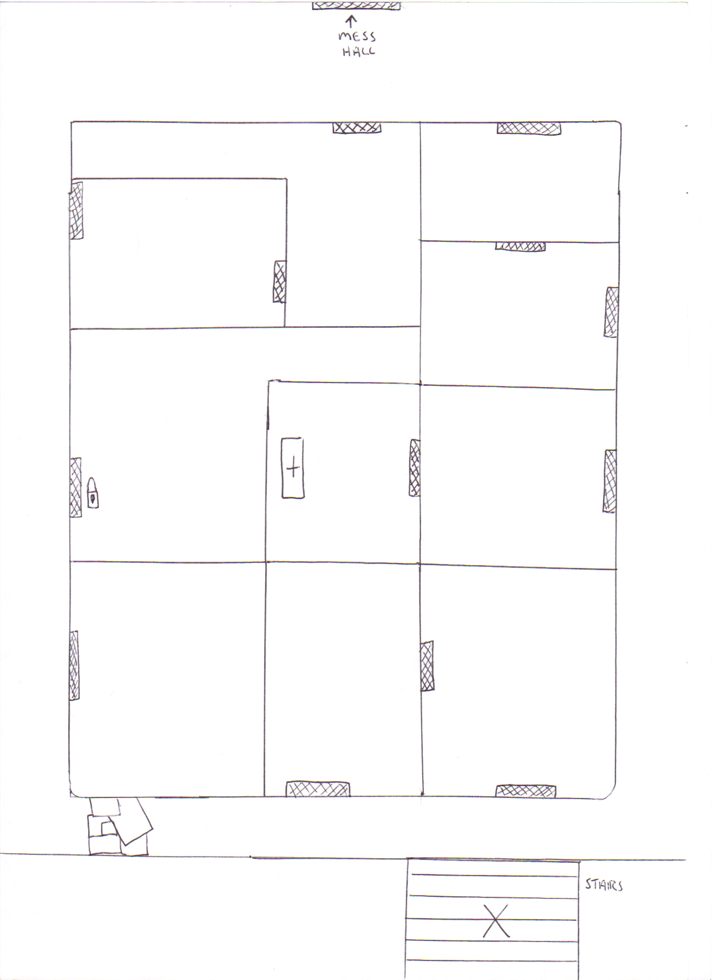

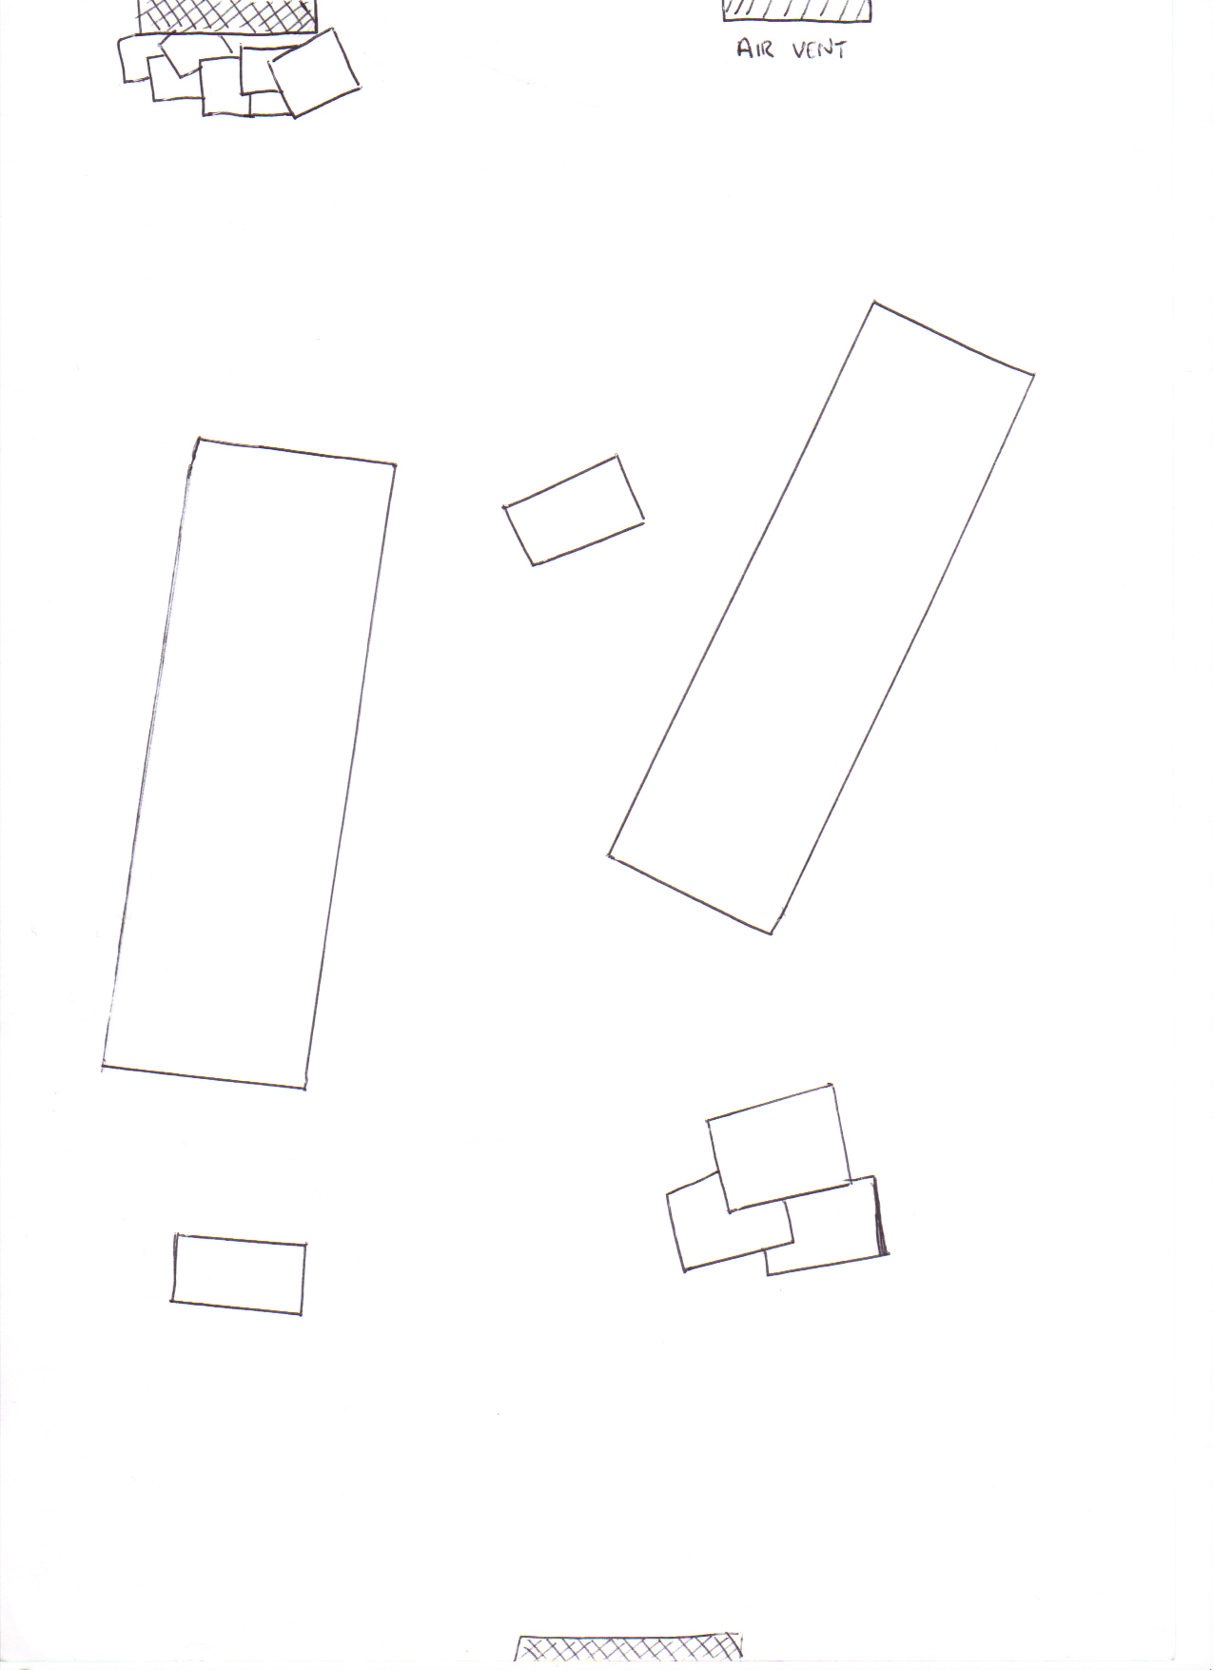

Crews Quarters and Mess Hall Resources
Sounds used in the level:

- For the mutated crew monster.wav1, monster.wav2, monster.wav3

- For the lights turning off lights off.wav

- For the lights turning on lightson.wav

Notes in level will read:
- I can hear them banging on the doors, trying to get in…
Their faces, I can almost still see my friends in them. There is no way out, tell my wife I’m sorry.
(By the corpse in the locked storage room)

- There’s another alarm, apparently we’ve to man battle stations but there’s no other ships out there!
What’s going on out there?

Medical and Armory
The player begins the level by exiting the air vent and comes out in the middle of a dark corridor. This corridor is straight and divides the medical bay to one side and the armory to the other. All doors are locked apart from the door to the medical bay, and as the player enters the room, there is a note found on a dead body which informs the player that the floor was locked down due to the security breach and the senior officer with the access codes was last seen in the medical store.
The player must make their way through several small cramped rooms to gain access to the medical store. Most rooms will be well lit, but one room will be lit with one small flickering lit. This is the point where the player is attacked by two enemies at either side of the room. To get to the next room the player must jump across some debris. The player will then have access to a health kit , and find that the storage room is blocked but another note hints at another way in. Moving back to the previous room, a crate can be destroyed which reveals a vent which takes the player into the medical store. As the crate is destroyed, the sound of a man and a creature screaming is played. Upon entering the medical store the player must kill another monster and collect the access code for the doors on this floor. The player can then move back to the main corridor and when the control panel is selected the doors of the level will open.
The player can then proceed through the far door to the next level of move into the armory to collect more weapons and ammo. The armory has a similar layout to the medical bay; several interconnected rooms. The difference however is that rooms are less well lit. The rooms are bigger and have many storage crates. After killing two enemies in the first room the player can move to the next room which is the store room, this is mostly empty but the is one weapon left, and also a box of ammo. In the quartermasters booth there will be another health kit. After collecting the weapon the player will be attacked by another monster, and when they move back to the corridor they will encounter two more creatures.

Communications Deck

This level will consist of a network of rooms of various sizes which contain numerous equipment and computer consoles. In this level the player must take the opportunity to repair some of the broken communications equipment so as to try and get in touch with some of his crew to secure some means of escape one the cargo has been collected.

The level begins with the player having to make their way to the main control room at the center of the deck. Once there the player will be informed that several key components are missing for the consol to operate, and so must collect the parts needed to repair it. These parts are scattered across the deck.

Each part is secured in a room which is reached by working through a network of rooms which are guarded by several enemies. There are three parts required, the first of which is reached by entering a block of conjoined rooms and in the last room there is another air vent which leads into a storeroom which is otherwise inaccessible.

The second part is at the end of another section of rooms but this time to access the final room with the part the player must climb a ladder into an overhead room and flip a switch. This opens the door and the player can then drop though a hole in the ceiling to get into a locked store room which contains extra ammo and health.

The final part is in a locker at the far end of a large room. To reach it the player must defeat four enemies which are stationed around the room. Once all three are collected the player can then return to the main room and turn on the communications device. Once this is complete the player can then proceed to the next level.

Engine Room
The player will begin the level in a small room with one door on the opposite wall. Upon exiting this room the player will be on a narrow walkway in a large room with high ceilings, and bellow will be an area submerged in water. The camera will move down bellow he water to show a submerged door, so as to indicate to the player the goal of the level.

To open this door the player must first activate the pump systems on this deck to drain the water from the lower level. By walking round the walkway there is a control room which can be accessed but a fuse on the main consol has blown. This means that the player must move round to a ladder on the far side of the walkway and climb this to reach the next section.

The top walkway will have several enemies and, once killed, the player can search the three rooms with lead off from this level. In the last room will be he fuse needed. The player can now return to the control room to activate the consol. Once this is done the player will be attacked by another wave of creatures.

The bottom level is now accessible and so the player can descend down another ladder to reach the ground floor. The player must navigate some debris and so they must jump and duck their way to the door. In this section, several caches of weapons and ammunition can be found.

Cargo Hold

This is the level where the games final boss will be encountered. It is the leader of the rival pirate ship who has somehow managed to find the secret weaponry before you.
As this level has only the one enemy, the level is fairly small and is similar to the last part of the previous level. There will be a large open room with several large crates which are scattered around due to the impact of hitting the shore. The player will work through this section, triggering several sound triggers along the way.

Eventually the player will reach an open clear area with several health packs dotted around the edges. A small cinematic will play and show he boss entering. The player must then defeat him to end the game and trigger the final cinematic.

HUD

The screen layout as seen by the player will be fairly basic and have a bar indicating the players health, the weapon selected and the amount of ammo available for that weapon.
Both the health bar and weapon details will be in the left and right bottom corners of the screen. The minimalist HUD has been implemented so that the player feels more drawn into the game and less like they are viewing a screen of stats and details.

Semester 2 schedule

Working in pairs;

Group 1

Week 1 - Bridge interior level creation + textures
Week 2 - Armory + Medical Level layout + textures
Week 3 - Armory + Medical Level layout + textures
Week 4 - Crew Quarters and Mess Hall layout + textures
Week 5 - Crew Quarters and Mess Hall layout + textures
Week 6 - Level assets for Bridge
Week 7 - Level assets for Armory and Medical
Week 8 - Level assets for Crew Quarters and Mess Hall
Week 9 - Matinee sequences for all levels.
Week 10 - Implement 3rd person view
Week 11 - Set enemies positions + AI
Week 12 - Check finished game, last min checks and tweaking.

Group 2

Week 1 - Bridge exterior level creation + textures
Week 2 - Engine Room layout + textures
Week 3 - Engine Room layout + textures
Week 4 - Communication Deck layout + textures
Week 5 - Communication Deck layout + textures
Week 6 - Cargo layout + textures
Week 7 - Level assets for Engine Room
Week 8 - Level assets for Comms deck
Week 9 - Level assets for Cargo + in game text for all levels.
Week 10 - Import additional textures for weapons + character
Week 11 - AI + double check game physics
Week 12 - Check finished game, last min checks and tweaking.

